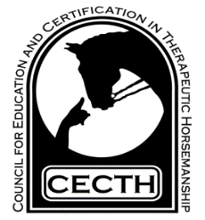
CECTH Virtual Annual Membership Meeting and Conference
Registration
8:30 AM – 3:30 PM, November 4 2023
Please send to CECTH office before November 1
Name ________________________________________________________________________
Address _______________________________________________________________________
_______________________________________________________________________
Email _________________________________________________________________________
Cell phone ______________________________

CECTH Member Registration: $75.00 _________
Non – Member Registration: $100.00 _________
Full Time Student (include a copy of school ID) _________
In event of a technical glitch, the complete video of the presentation will be sent to registrants.
Method of Payment:
Check (payable to CECTH) ____; PayPal (on the CECTH website) ____ Credit Card ____
For Credit Card payment: Name as it appears on card_________________________________
Card Number ____________________________________________
Expiration Date _______ CVV# ______ Zip Code ________________
I authorize CECTH to charge my card for the amount listed above:
_______________________________________________________
Address: CECTH, 9794 Old Hawn Rd. Huntingdon, PA 16652; 814-667-2497; info@cecth.org
Schedule
(4 ceu’s)

8:30 – Welcome
8:40 – 9:40, Appropriate Exercises for Muscle Dysfunction and Disabilities
Dr. Carmon Weldi, PT
9:50 – 10:50, Panel Discussion, Lesson Planning and More, Moderators:
Stephanie Fleck, Caitlin O’Neal, Danielle Denlinger
11:00 – 12:00, The Importance of Correct Saddle Fit for Horse and Rider
Terry Peiper, Fit Right Saddle Solutions
12:00 – 12:30, Annual Membership Meeting
12:30 – 1:00, Lunch Break
1:00 – 2:00, Behavior Supports for Riders and Deceleration of Difficult
Situations
2:15 – 3:15, continued: Behavior Supports for Riders and Deceleration of
Situations
Lisa Kruse, Behavior Specialist, TIU 11
3:15, Close

Thank you to all presenters
and
Thank you to all attendees!

